Grocery Store Database System

Team: Damian, Ryan, Kamil, Anastasija
CA Description:
Our idea for this CA is a grocery store database system. This database has information on products, employees, store branches, and customers.
The product section contains information such as category (e.g., dairy, fruits, bakery, meat, protein), stock levels, expiry dates, price, and product deliveries. The employee section contains information such as job title, wage, name, branch location, phone number, address, and assigned shifts. The customer section contains information such as name, age, phone number, and email. Customers visits to branches are also tracked. The store branch section contains information such as address, website, opening hours, phone number, and email.
The system should store, organise and manage all the data efficiently, which would allow the grocery store to handle daily tasks more efficiently. This database would reduce manual work and would connect all parts of the store in one database.
This grocery store database system would greatly improve the efficiency and organisation of store operations. It integrates multiple aspects of the business from inventory management to customer relations into a single working system by automatic data handling this system should help reduce manual errors.

Entities and Attributes
STORE_BRANCH – branch_id (PK), address, website, phone_number, email, opening_hours
CUSTOMER – customer_id (PK), customer_name, customer_age, phone_number, email
EMPLOYEE – employee_id (PK), employee_name, date_of_birth, address, phone_number, job_title, wage, branch_id (FK)
PRODUCT – product_id (PK), name, price, expiry_date, stock, category, branch_id ()
DELIVERY – delivery_id (PK), cost, delivery_date, amount
DELIVERY_DETAILS – delivery_id (FK), product_id (FK), quantity, Composite PK: (delivery_id, product_id)
CUSTOMER_VISITS – customer_id (FK), branch_id (FK), Composite PK: (customer_id, branch_id)
EMPLOYEE_LOCATION – employee_id (FK), branch_id (FK), start_date, end_date, Composite PK: (employee_id, branch_id, start_date)
BRANCH_PRODUCT_STOCK – branch_id (FK), product_id (FK), quantity, Composite PK: (branch_id, product_id)

Relationships
Customer - Customer_Visits - Store_Branch – M:N
Employee - Store_Branch – 1:M
Employee - Employee _Location - Store_Branch – M:N
Product – Store_Branch – 1:M
Store_Branch - Branch_Product_Stock - Product – M:N
Delivery - Delivery_Details - Product – M:N
Customer - Customer_Visits – M:N

Schema:
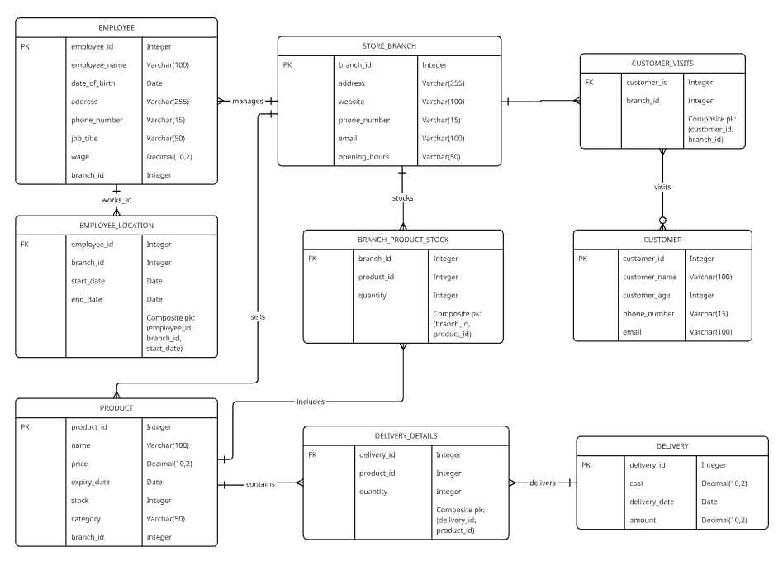
Normalisation
Chosen relationships:
Many to many <--> deliveries
One to many --> deliveries

Unnormalized data
BranchID | BranchAddress | Delivery ID | Product1_Name | Product2_Name | DeliveryDate
B001 | 67 Main St dundalk | D2001 | Whole Milk 3L | Mangos 1Kg | 25/10/2025

(1NF) First Normal Form
DeliveryID | Branch  ID | DeliveryDate | ProductID | ProductName | Category | Qty | Unit  Cost | Expiry  Date
D2001 | B001 | 25/10/2025 | P001 | Whole Milk 3L | Dairy | 1 | 3.65 | 28/10/2025

(2NF) Second Normal Form
Key: Delivery ID , Product ID , Expiry Date
Problem is that ProductName and category depend on ProductID and BranchID depends on DeliveryID
To solve this problem we Split the tables into seperate ones

Table 1 : Delivery
DeliveryID | BranchID | DeliveryDate
D2001 | B001 | 25/10/2025

Table 2 : Delivery Item
DeliveryID | ProductID | ExpiryDate | Qty | UnitCost
D2001 | P001 | 28/10/2025 | 1 | 3.65

Table 3 : Product
ProductID | ProductName | CategoryID | StandardPrice
P001 | Whole Milk 3L | D001 | 3.80

Table 4 : StoreBranch
BranchID | Address | OpeningHours | Phone
B001 | 67 Main St dundalk | Mon-Sat 8-21 | 0873467089

Table 5 : Category
CategoryID | CategoryName
D001 | Dairy

(3NF) Third Standard Form

StoreBranch (BranchID, Address, OpeningHours, Phone, Email , Website)
Delivery ( DeliveryID, BranchID[FK], DeliveryDate)
DeliveryItem ( DeliveryID[FK], ProductID[FK], ExpiryDate, Qty, UnitCost)
Primary Key: (DeliveryID, ProductID, ExiryDate)

Triggers:
Stored Procedures:
Database Administration:
Transactions:

